TOP 10 CORPORATE TEAM BUILDING ACTIVITIES
“If you want to feel secure
Do what you already know how to do.
But if you want to grow…
Go to the cutting edge of your competence,
Which means a temporary loss of security.
So, whenever you don’t quite know
What you are doing
Know
That you are growing…”
(David Viscott, 2003)

Team building is a process of transforming a group of people into a cohesive team, whereby they can practice and enjoy healthy interpersonal relationship. Effective teams work together through effective and efficient collaboration, cooperation and interdependently meet organizational goals and objectives. The most important element of team members is not only accomplishing group tasks, but trust and support one another while respecting individual differences.
At an individual level, employees may function productively. However, at a group level, employees may have several issues working with peers and other staff members. This might range from ineffective interpersonal communication, lack of trust, decreased motivation to conflict management and diminished employee morale. As a result of this, organizational performance decreases along with diminished ROI.
Team building activities helps an organization to enhance the behavioral and experiential skill sets of its employees that giving rise to effective functioning of cross functional teams. Team building activities are more application oriented rather than classroom focused. Participants in a team building program are challenged by the trainers or facilitators to achieve a specific goal. In the process, the facilitators does not help in completing the challenge, but ensures that the participants must work together as an individual and as a team in an organizational setting so as to find a solution through a collaborative work environment. The participants undergo experiential learning followed by reflection, discussion, analysis and evaluation. Team building activities paves a way for collaboration, leadership and innovation at workplace.
A team building program is first initiated through need analysis, followed by program design, conducting activities through trained facilitators and closing it with debriefing and feedback. Designing a team building program is crucial to the success or failure of the training initiatives undertaken by the organization for its team.
The various benefits of delivering team building games and activities are as follows:
- Productivity is enhanced by identifying and removing obstructions and improving existing ways of working.
- Employees use creativity and lateral thinking by moving employees away from traditional method of job setting which refresh and recharge them.
- Helps in solving problems and taking decisions in the form of agile training through multiple participation
- Motivated and collaborative work culture is facilitated bringing individual together under one umbrella
- Employees are more aware about their personality , strengths, desires and weaknesses through responsive and meaningful conversation
- Employee morale is boosted, thus increasing employee retention
- It helps in conflict resolution and gives a sense of ownership
- It acts a positive reinforcement ,building trust and promoting interdependence
- The learning and the insights can be transferred to actual work, resulting in better group dynamics and work performance
- It is creates a platform for experiential learning thus helping participants make a permanent change in their behavior

Top 5 Outbound Team Building Activities

- Egg Drop
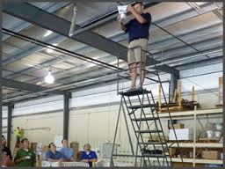
Fig: Egg Drop
Time: 30 -45 minutes
Number of Participants: 5-8 participants/group
Methodology: Split everyone off into groups of five to eight people and give each group an uncooked egg. Put all the office supplies in a pile. They have 15 to 30 minutes to use the supplies to build a contraption around the egg that will keep the egg from breaking when dropped. Some suggestions for supplies are: tape, pencils, straws, plastic utensils, packing material, newspapers, and rubber bands. Once time is up, drop each egg contraption from 3 meters hoping that it will prevent the egg from breaking upon impact
Learning Objectives/ Outcomes: Inspires creativity, Fosters teamwork, Zany task, Thrilling climax.

- Longest Chain
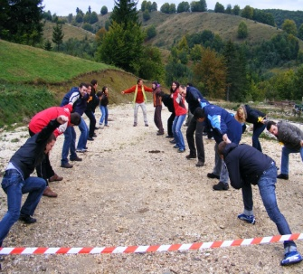

Fig: Longest Chain

Time: 30 minutes
Number of Participants: 40
Methodology: Groups will have to form a human chain as long as they can hold just the hands. Later they are encouraged to think on how they can use other resources to form the longest line and create the longest string.
Learning Objective/Outcomes: Creativity, Thinking out of the box, Overcoming limitations, Team Work

- Toxic Waste/Atomic Waste

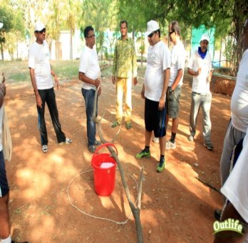
Fig: Atomic Waste

Time: 35- 60 minutes
Number of Participants: 8-12 (A minimum of 6 can also be made)
Methodology: A 8-10 feet rope is used to create a toxic waste radiation zone on the ground. The challenge increases with the size of the zone. A platform is placed (might be a tool) at the middle of the circle. A bucket is filled with water and placed at the centre of the radiation zone. 2 ropes are kept ready for use outside the radiation zone. The challenge is how to transport the toxic waste bucket from the radiation zone to the safe zone so as to avoid the blast which could destroy the world. The participants have to do this activity with the equipment provided. Any participants entering into the radiation zone will have fatal injury. So it is important that the participants will not enter the radiation zone and keep themselves safe. During the game no one is allowed to retrieve the toxic waste.
Learning objectives/Outcomes: Communication, Decision Making, Planning, Problem Solving, Leadership, Teamwork

- Balloon Relay

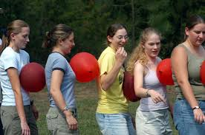

Fig: Balloon Relay

Time: 15 minutes
Number of Participants: 10- 15 people
Methodology: One inflated balloon per participant and a mask should be kept ready at hand.
Two groups are made each with 5 to 7 people. An inflated balloon is kept between two participants, except the first and the last pair. They should not touch the balloon with their hands. They need to walk towards the finishing line as a group. If any balloon touched the ground, the employee will have to restart the process. The group which reaches first wins the game.
Learning Objectives/Outcomes: Focus, team building, interpersonal communication

- Blindfold maze

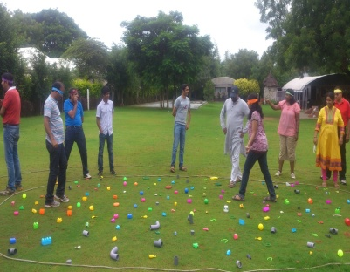

Fig: Blindfold Maze

Time: 15 minutes
Number of Participants: 10- 15
Methodology: At first, the participants are blindfolded except the leader, who gives instructions to them. The blindfold participants touch the shoulders of the participants in front of them while they stand in a straight line. Various obstacles are kept for the participants to overcome as they move forward. The leaders give the instructions to move and the participants move together. The participants move through the obstacles and the leader is not allowed to touch the participants. The round gets complete when the last participant crosses the finishing line.
Learning Objectives/Outcomes: Communication, Trust and Team Building
Top 5 Indoor Team Building Activities
- Newspaper Tower
Fig: Newspaper Tower

Time: 30 minutes
Number of participants: 6-15
Methodology: A pile of newspapers are collected and given to each team. The teams have to make tallest tower within a stipulated time without using stables, cello tape, glue etc. The team which creates the highest tower win the activity.
Learning Objectives/ Outcomes: team building, group dynamics, creativity, communication

- Magic Carpet

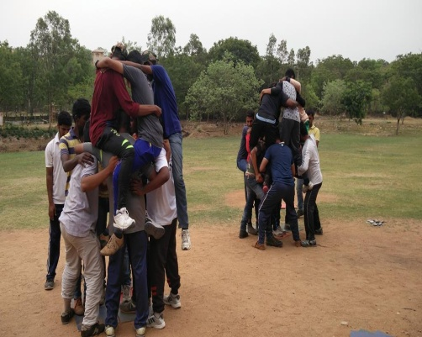
Fig: Magic Carpet

Time: 30 minutes
Number of Participants: 5-7
Methodology: Participants are not allowed to put their feet on the ground. As a team, they stand at the top of their tarp and is then asked to "flip" the tarp over without anyone touching the ground. They keep on repeating it unless they reach their finishing line.
Learning Objectives/ Outcomes: Motivation, understanding the strengths of co workers, leadership, strategy and communication.

- Blind Drawing

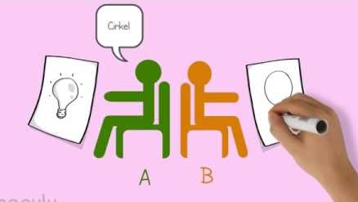
Fig: Blind Drawing

Time: 10-15 minutes
Number of participants: 2 people per group
Methodology: The participants are divided into groups of two people. Both the participants sit back to back. One participant is given a picture and the other a pen and paper. The person holding the picture describes the picture without telling naming/telling it. The other person draws it. In the next round role gets reverse. The team which would be closer to the correct drawing wins.
Learning Objectives/Outcomes: Interpretation, communication, Creative thinking

- Hula Hoop Pass

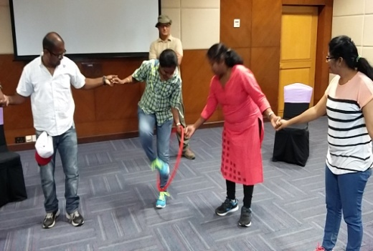

Fig: Hula Hoop Pass

Time: 10 minutes
Number of participants: 5-25
Methodology: The group forms a circle holding hands. The task of the team is to pass the hula hoop around the circle in a specific direction, so that it returns to the starting point. A variation of this activity can be done by using two hoops (a rope equivalent in size of the hula and a hula ) moved towards the opposite direction.
Learning Objectives/Outcomes: Inter dependence, coordination, creativity

- The Barter Puzzle
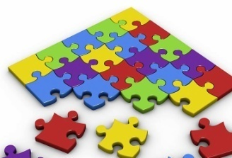

Fig: The Barter Puzzle

Time: 45 – 60 minutes
Number of participants: 5-7 per group
Methodology: Each group is given different jigsaw puzzles with the same difficulty level. The goal is to find which group completes the puzzle first. Some jigsaw puzzle pieces will be mixed around with the other group’s puzzle. It is upon the team to come up and collect their pieces from the other teams.
Objective: Problem solving, leadership skills, communication, synergy, decision making

These are one of the most engaging top ten corporate teambuilding activities which HR managers can incorporate in their employee engagement programs so as to bring about change in the organizational culture and processes for an effective and efficient outcome.

Outlife has been a pioneer for innovation in the field of outbound and experiential education learning. Some of the top team building games conducted by Outlife includes Human Knots, Spider Web, Paper Tower, Pictionary, Quick Draw, Survival Island, Moon Ball, Helium Stick, Balloon Race, Hula Hoop Circle, Hula Frenzy, Blindfold polygon, Change Wave, Balloon Keep up. Some of the indoor learning methodologies include Scenario Based Learning, Drama Based Learning, Art Based Learning, Fun Based Learning, Simulation Games, Business Games, Management Games, Group Discussions, Film Making,
Story Telling, Painting, Creativity Games, Mystery Games, and Role Plays.

